Day76-78 - Challenge11 - Terraform Challenge02

Task 1: Containerize and Deploy a Static Web Server Behind a Load Balancer with Terraform

Objective
To write a Dockerfile for the static web server; write Terraform resource and module blocks for the ECR repository and image push, VPC, Internet Gateway, public subnets and route table, ALB and instance security groups, Application Load Balancer with target group and listener, a Terraform-generated SSH key pair, an IAM role for ECR pull access, and the Ubuntu instance with a Docker-install-and-run user_data script; apply them in one pass; and confirm the web server responds only through the Load Balancer's DNS name.

Prerequisites:
- Terraform CLI installed locally (verified with terraform -version).
- Docker installed locally with the daemon running, used to build the image before terraform apply.
- Valid AWS credentials configured (AWS CLI profile / environment variables) with permission to create ECR repositories, VPCs, subnets, route tables, internet gateways, security groups, IAM roles, Application Load Balancers, and EC2 instances.
- The operator's current public IP address, to scope SSH access.
- A clean working directory for the configuration, e.g. terraform-docker-webserver/.

Step 1: Dockerfile and Static Page
- Create app/Dockerfile, based on nginx:alpine, that serves a static HTML page from app/html/.
FROM nginx:alpine

RUN rm -rf /usr/share/nginx/html/*
COPY html/ /usr/share/nginx/html/

EXPOSE 80

HEALTHCHECK --interval=30s --timeout=3s CMD wget -qO- http://localhost/ ||
exit 1
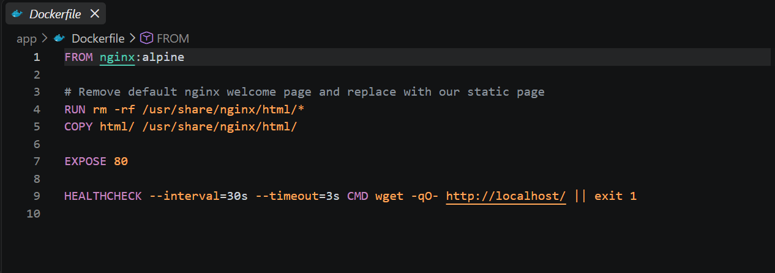Local editor showing app/Dockerfile and app/html/index.html

Step 2: Build the Image Locally
- Before running any Terraform, build the image locally so it exists for Terraform to push in Step 4.
cd app
docker build -t static-webserver:latest .
cd ..
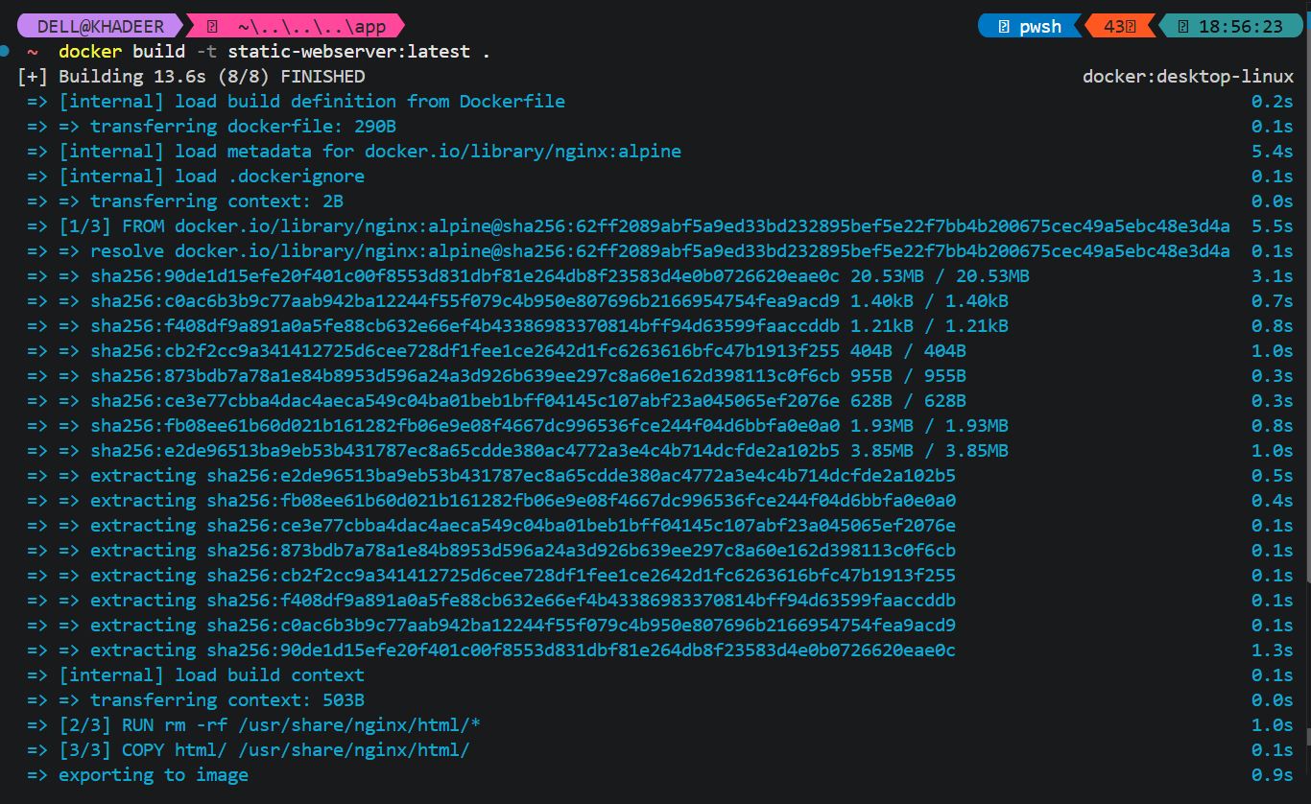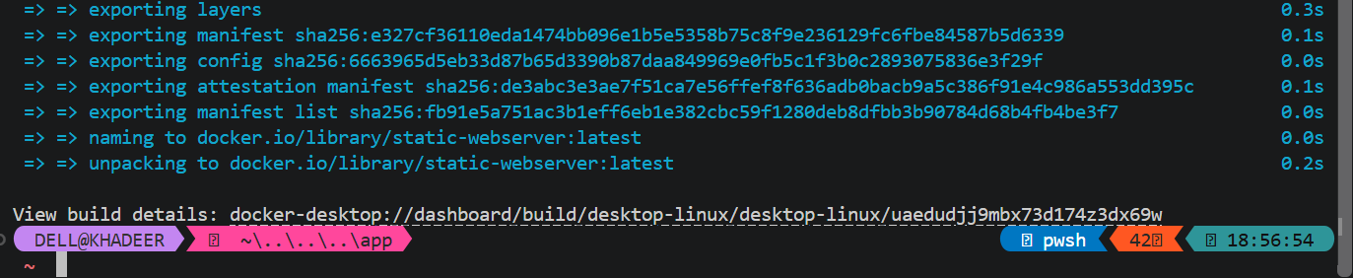

Step 3: Custom VPC, Internet Gateway, Public Subnets and Route Table
- In modules/vpc, declare the VPC, an Internet Gateway, two public subnets (one per Availability Zone, required by the ALB), and a route table with a 0.0.0.0/0 route to the gateway.
resource "aws_vpc" "this" {
cidr_block = var.vpc_cidr
enable_dns_support = true
enable_dns_hostnames = true
tags = { Name = "${var.name_prefix}-vpc" }
}

resource "aws_internet_gateway" "this" {
vpc_id = aws_vpc.this.id
tags = { Name = "${var.name_prefix}-igw" }
}

resource "aws_subnet" "public" {
count = length(var.public_subnet_cidrs)
vpc_id = aws_vpc.this.id
cidr_block = var.public_subnet_cidrs[count.index]
availability_zone = var.availability_zones[count.index]
map_public_ip_on_launch = true
tags = { Name = "${var.name_prefix}-public-${count.index + 1}" }
}

resource "aws_route_table" "public" {
vpc_id = aws_vpc.this.id
route {
cidr_block = "0.0.0.0/0"
gateway_id = aws_internet_gateway.this.id
}
tags = { Name = "${var.name_prefix}-public-rt" }
}

resource "aws_route_table_association" "public" {
count = length(aws_subnet.public)
subnet_id = aws_subnet.public[count.index].id
route_table_id = aws_route_table.public.id
}

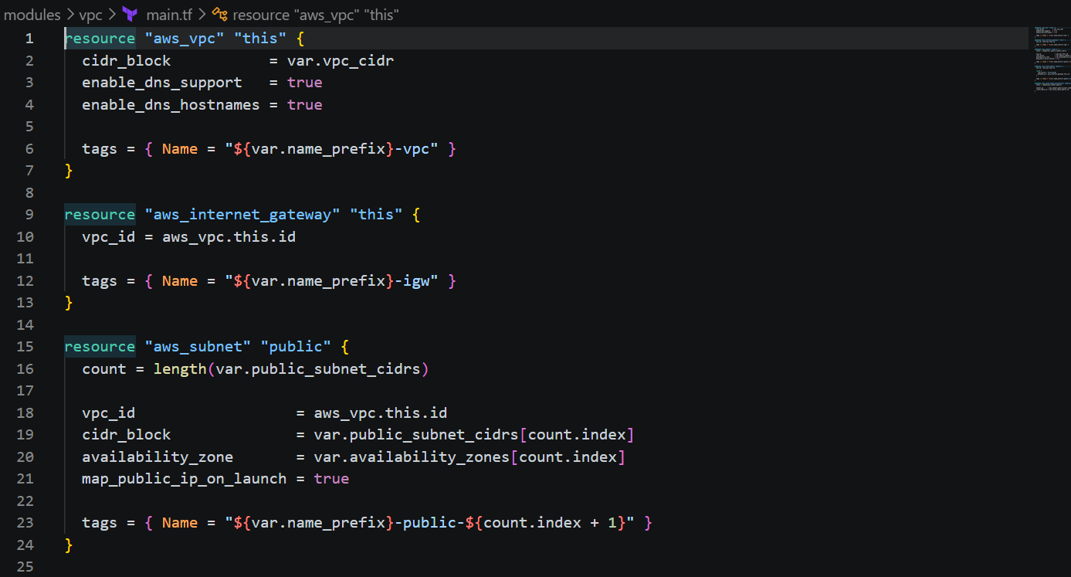
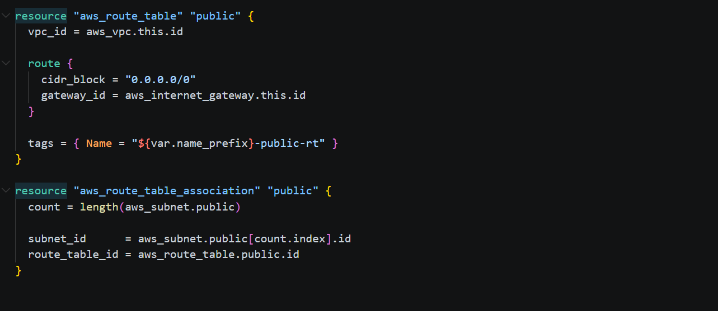
Local editor showing modules/vpc/main.tf with the vpc, internet gateway, subnet, and route table blocks

Step 4: ECR Repository and Image Push
- In modules/ecr, declare the ECR repository, then a null_resource that logs in to ECR, tags the local image built in Step 2 with the repository URL, and pushes it — using Terraform to move the local image into the registry as required.
resource "aws_ecr_repository" "this" {
name = var.repository_name
image_tag_mutability = "MUTABLE"
force_delete = true
image_scanning_configuration {
scan_on_push = true
}
tags = { Name = "${var.name_prefix}-ecr" }
}

resource "null_resource" "docker_push" {
triggers = {
repository_url = aws_ecr_repository.this.repository_url
image_tag = var.image_tag
image_digest = timestamp()
}

provisioner "local-exec" {
command = <<-EOT
set -e
aws ecr get-login-password --region ${var.aws_region} \
| docker login --username AWS --password-stdin ${aws_ecr_repository.this.repository_url}
docker tag ${var.local_image_name} ${aws_ecr_repository.this.repository_url}:${var.image_tag}
docker push ${aws_ecr_repository.this.repository_url}:${var.image_tag}
EOT
}

depends_on = [aws_ecr_repository.this]
}

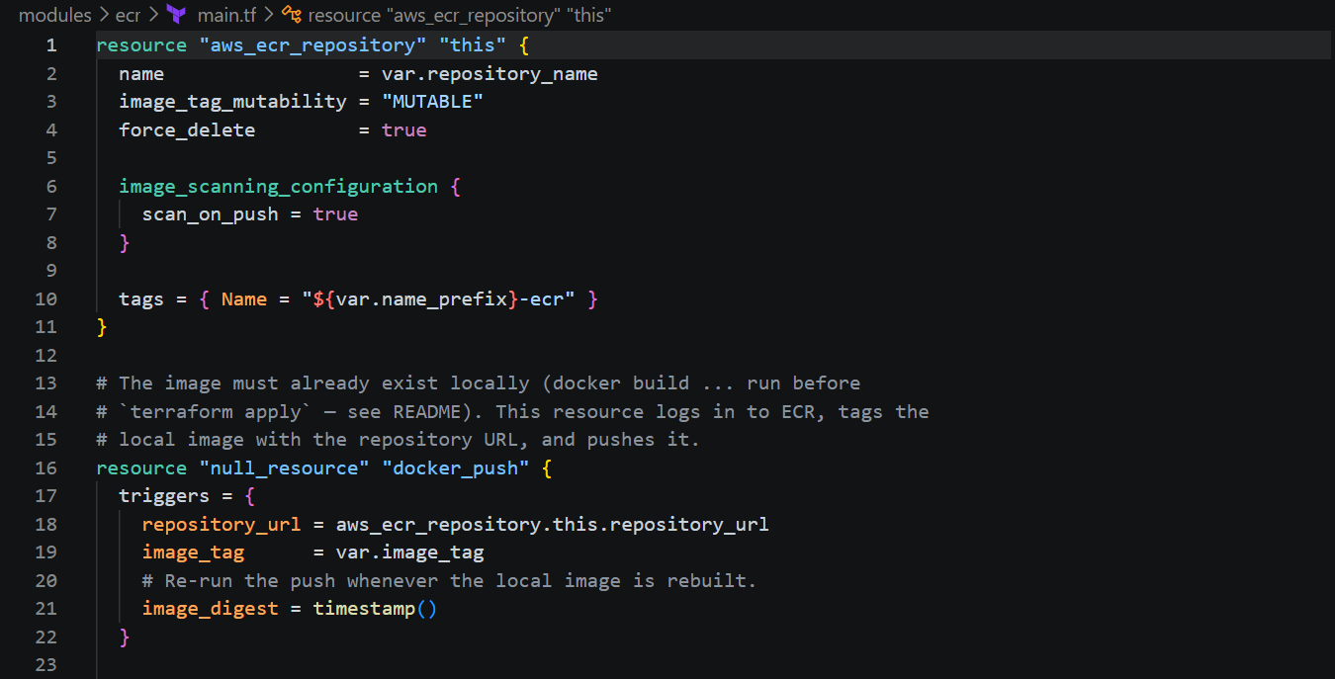
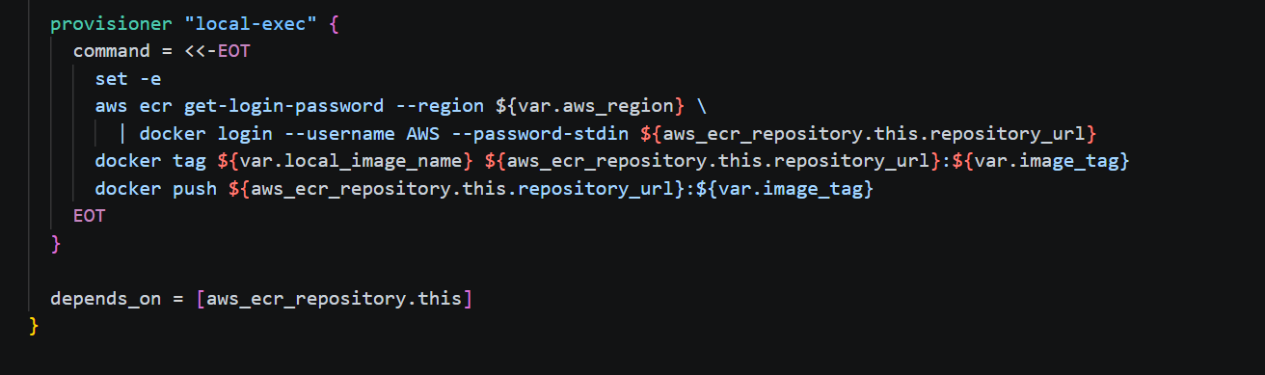
Local editor showing modules/ecr/main.tf, and terminal output of docker push succeeding during terraform apply

Step 5: Security Groups for the Load Balancer and the Instance
- In modules/security, create an ALB security group opening 80/443 to the internet, and an instance security group that only accepts port 80 from the ALB's security group and port 22 from the operator's allowed CIDRs.
resource "aws_security_group" "alb" {
name = "${var.name_prefix}-alb-sg"
vpc_id = var.vpc_id
ingress {
from_port = 80
to_port = 80
protocol = "tcp"
cidr_blocks = ["0.0.0.0/0"]
}
ingress {
from_port = 443
to_port = 443
protocol = "tcp"
cidr_blocks = ["0.0.0.0/0"]
}
egress {
from_port = 0
to_port = 0
protocol = "-1"
cidr_blocks = ["0.0.0.0/0"]
}
}

resource "aws_security_group" "instance" {
name = "${var.name_prefix}-instance-sg"
vpc_id = var.vpc_id
ingress {
from_port = 80
to_port = 80
protocol = "tcp"
security_groups = [aws_security_group.alb.id]
}
ingress {
from_port = 22
to_port = 22
protocol = "tcp"
cidr_blocks = var.allowed_ssh_cidrs
}
egress {
from_port = 0
to_port = 0
protocol = "-1"
cidr_blocks = ["0.0.0.0/0"]
}
}
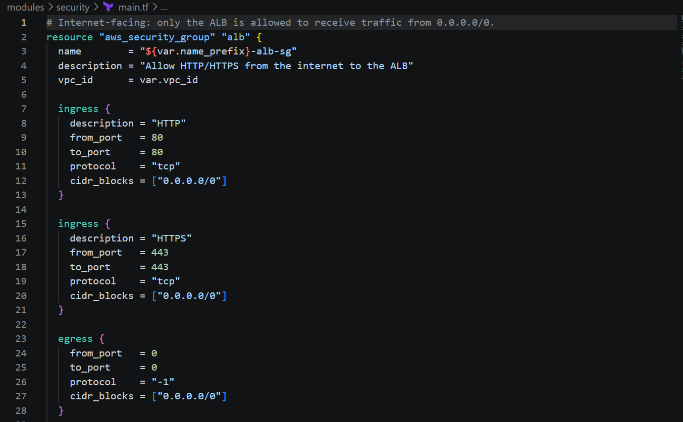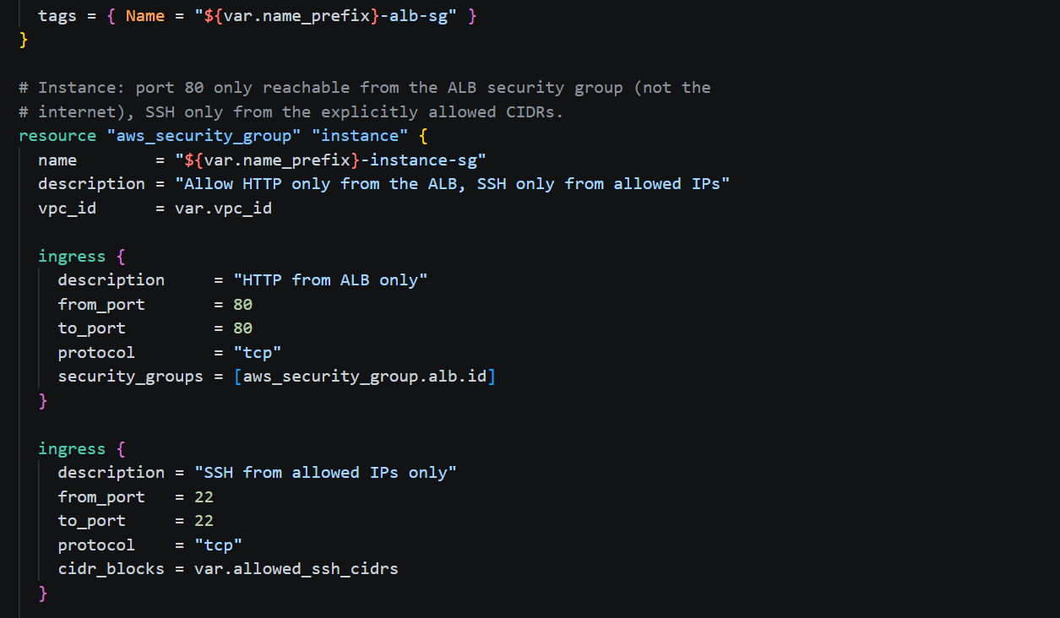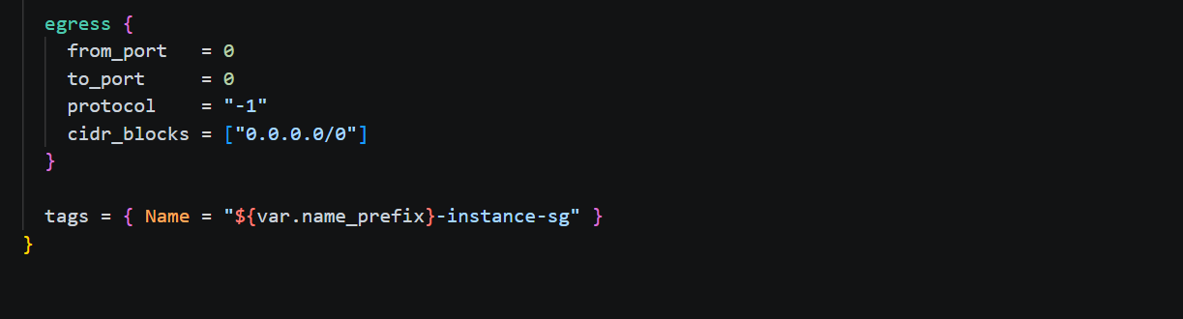
Local editor showing modules/security/main.tf with both security group blocks

Step 6: Application Load Balancer, Target Group and Listener
- In modules/alb, create the ALB across both public subnets, a target group with a health check on "/", and an HTTP listener forwarding to that target group.
resource "aws_lb" "this" {
name = "${var.name_prefix}-alb"
internal = false
load_balancer_type = "application"
security_groups = [var.alb_sg_id]
subnets = var.public_subnet_ids
}

resource "aws_lb_target_group" "this" {
name = "${var.name_prefix}-tg"
port = 80
protocol = "HTTP"
vpc_id = var.vpc_id
target_type = "instance"
health_check {
path = "/"
healthy_threshold = 2
unhealthy_threshold = 5
interval = 30
matcher = "200"
}
}

resource "aws_lb_listener" "http" {
load_balancer_arn = aws_lb.this.arn
port = 80
protocol = "HTTP"
default_action {
type = "forward"
target_group_arn = aws_lb_target_group.this.arn
}
}
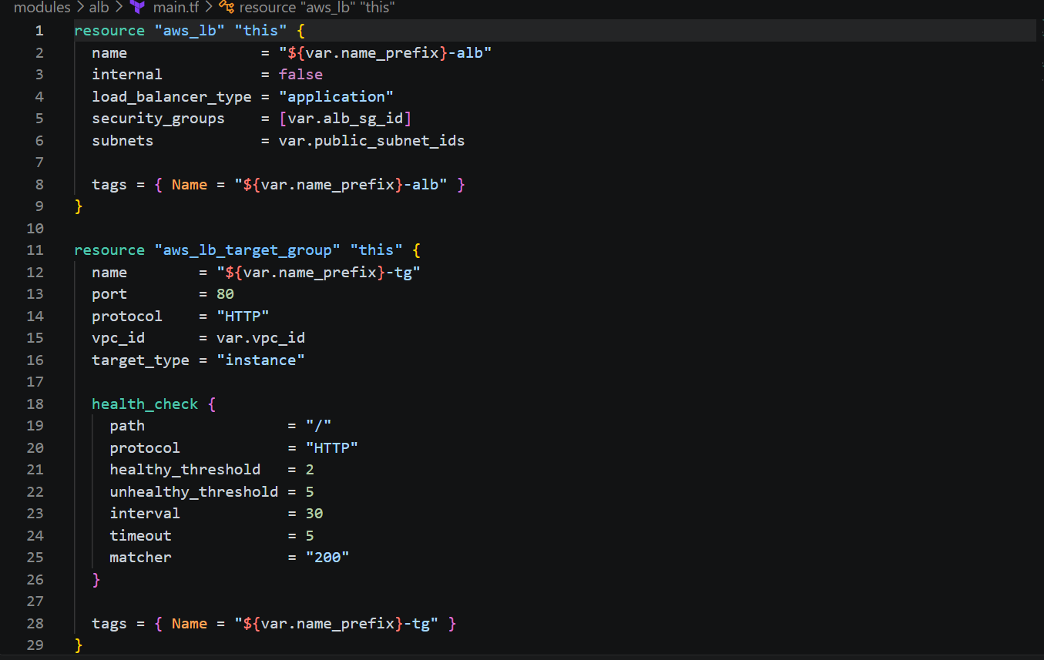
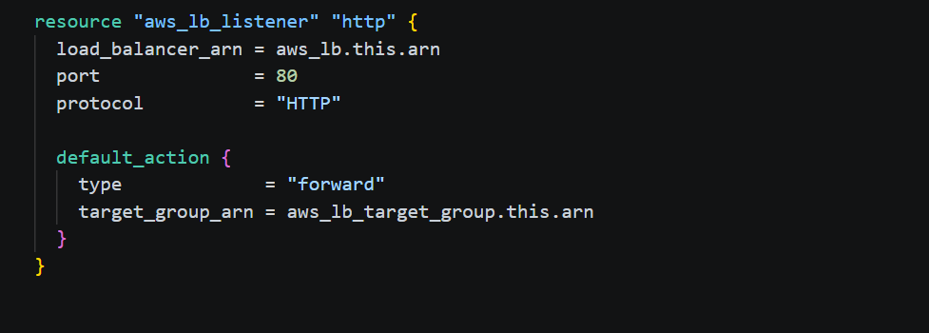
Local editor showing modules/alb/main.tf with the aws_lb, aws_lb_target_group, and aws_lb_listener blocks

Step 7: SSH Key Pair, IAM Role, and Ubuntu Instance with user_data
- In modules/ec2, generate an SSH key locally with tls_private_key, register it with AWS as an aws_key_pair, and attach it to the instance. Create an IAM role with the AmazonEC2ContainerRegistryReadOnly policy so the instance can pull from ECR without static credentials, then launch the Ubuntu instance with a user_data script that installs Docker, logs in to ECR, pulls the image pushed in Step 4, and runs it.
resource "tls_private_key" "this" {
algorithm = "RSA"
rsa_bits = 4096
}

resource "aws_key_pair" "this" {
key_name = "${var.name_prefix}-key"
public_key = tls_private_key.this.public_key_openssh
}

resource "aws_iam_role" "ec2_ecr" {
name = "${var.name_prefix}-ec2-ecr-role"
assume_role_policy = data.aws_iam_policy_document.ec2_assume.json
}
resource "aws_iam_role_policy_attachment" "ecr_read" {
role = aws_iam_role.ec2_ecr.name
policy_arn = "arn:aws:iam::aws:policy/AmazonEC2ContainerRegistryReadOnly"
}
resource "aws_instance" "this" {
ami = data.aws_ami.ubuntu.id
instance_type = var.instance_type
subnet_id = var.subnet_id
vpc_security_group_ids = [var.instance_sg_id]
key_name = aws_key_pair.this.key_name
iam_instance_profile = aws_iam_instance_profile.this.name
user_data = templatefile("${path.module}/user_data.sh.tpl", {
aws_region = var.aws_region
ecr_repository_url = var.ecr_repository_url
docker_image_tag = var.docker_image_tag
})
}
resource "aws_lb_target_group_attachment" "this" {
target_group_arn = var.target_group_arn
target_id = aws_instance.this.id
port = 80
}

- User_data.sh.tpl:
#!/bin/bash
set -e
apt-get update -y
apt-get install -y docker.io awscli
systemctl enable docker
systemctl start docker

aws ecr get-login-password --region ${aws_region} \
| docker login --username AWS --password-stdin ${ecr_repository_url}

docker pull ${ecr_repository_url}:${docker_image_tag}

docker run -d --name static-webserver --restart unless-stopped \
-p 80:80 ${ecr_repository_url}:${docker_image_tag}

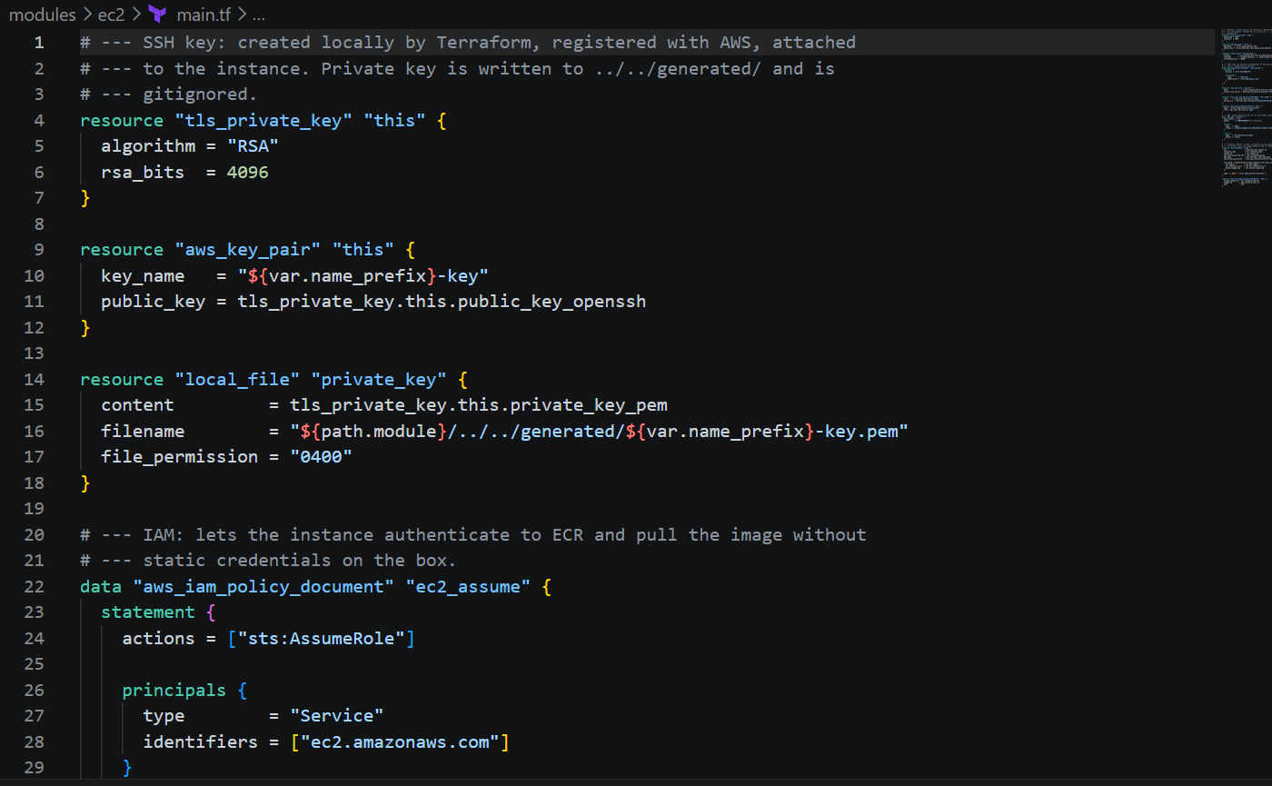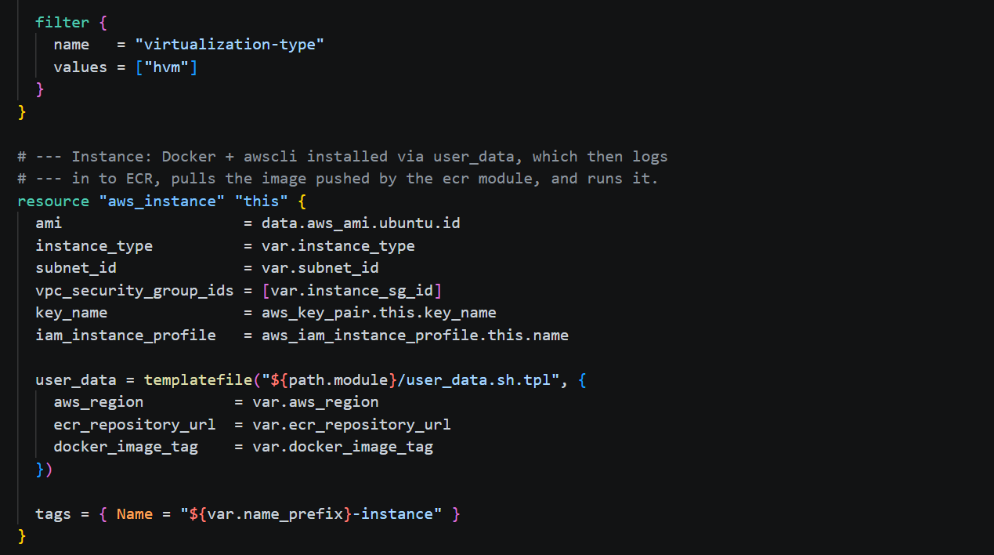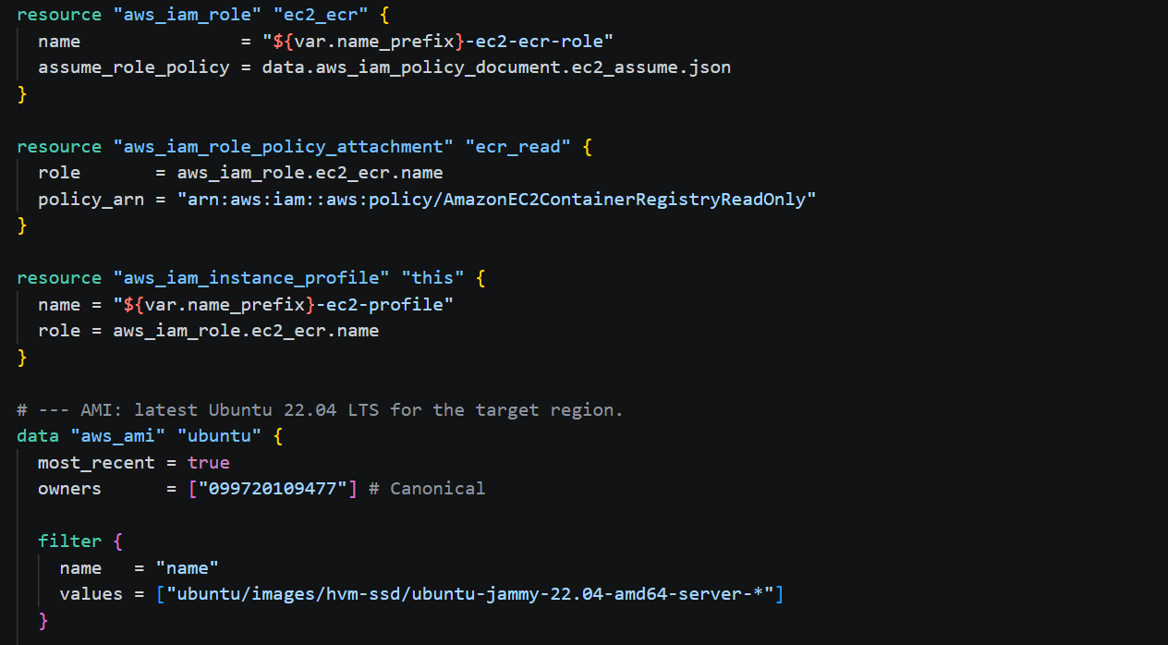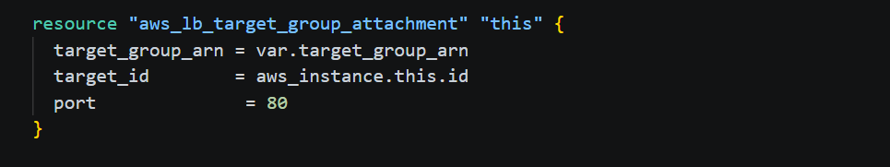
Local editor showing modules/ec2/main.tf and user_data.sh.tpl

Step 8: Initialize, Plan, and Apply
- Copy terraform.tfvars.example to terraform.tfvars, set allowed_ssh_cidrs to the operator's own IP, then run:
terraform init
terraform plan
terraform apply

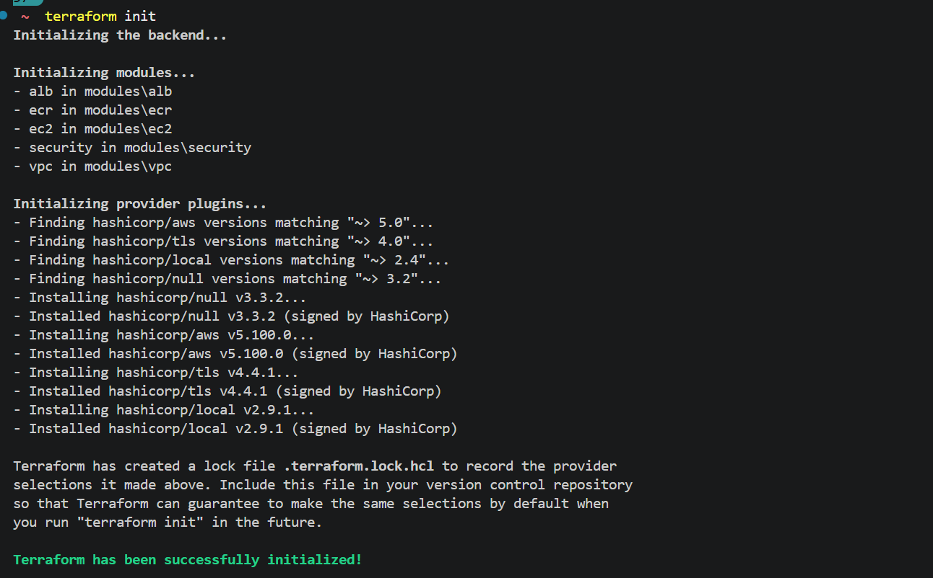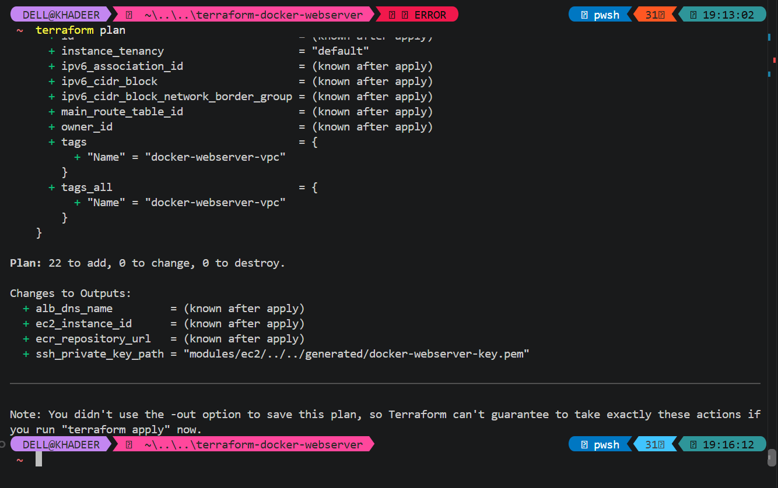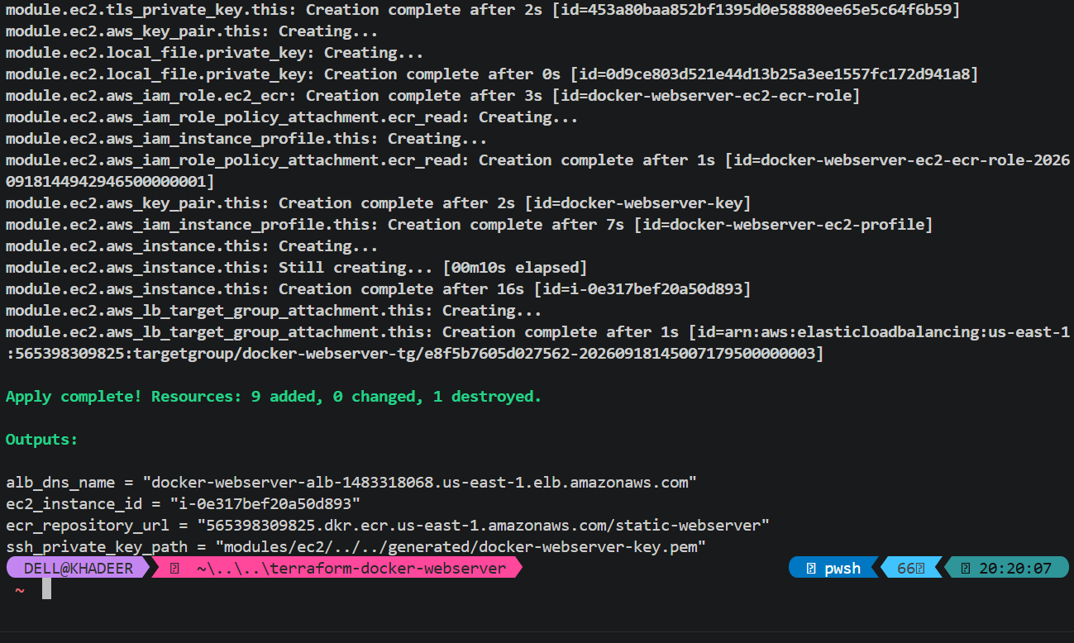
Terminal output of terraform apply completing with “Apply complete!” and the alb_dns_name output

Step 9: Verify the Service Over the Load Balancer Only
- Wait roughly one to two minutes for user_data to finish and for the target group health check to pass, then curl the ALB's DNS name. A direct request to the instance's own IP on port 80 should time out, since its security group only accepts port 80 from the ALB.
http://$(terraform output -raw alb_dns_name)
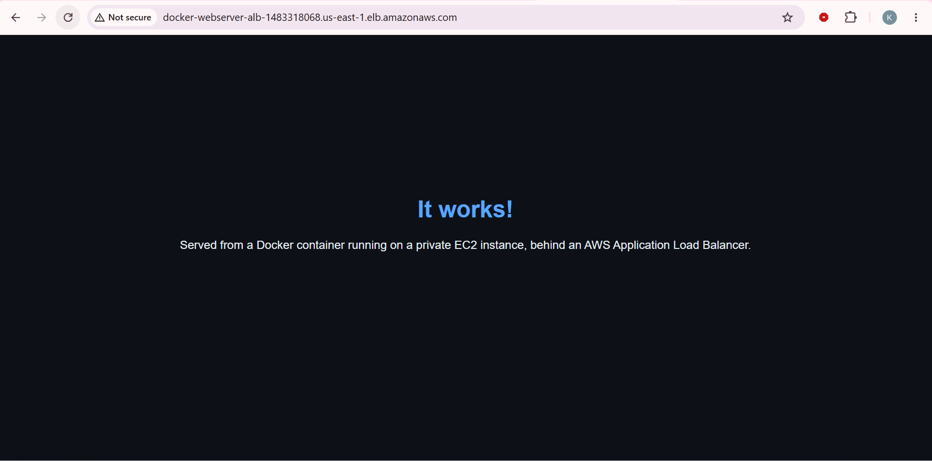Browser or curl output showing the static page served over the ALB DNS name, and target group health status “healthy” in the AWS console
Validation Steps
- terraform apply completes with “Apply complete!” and no errors.
- The ECR repository shows the pushed image tag, confirmed by docker push output and the AWS console.
- The VPC, Internet Gateway, public subnets, and route table all appear in the AWS console and are correctly linked.
- The ALB security group shows inbound 80/443 open to 0.0.0.0/0; the instance security group shows port 80 open only to the ALB security group and port 22 open only to the configured CIDRs.
- The target group shows the instance as healthy.
- curl against the ALB DNS name returns the static page; the same request against the instance's own public IP does not succeed.
- SSH with the generated key succeeds from an allowed IP and is refused from any other IP.

